1. chmod: This command is used to change the file or directory permissions.

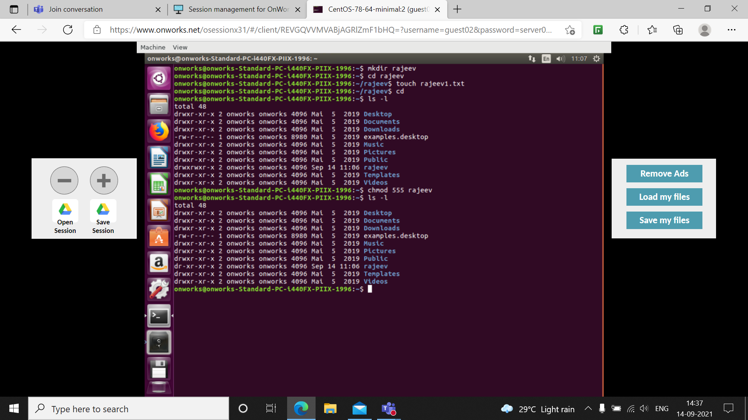

2. cat -n filename: This option of cat Is used to display content of file with line number.
cat filename1 >filename2: This option is used to over write filename2 with the contents
of filename1.
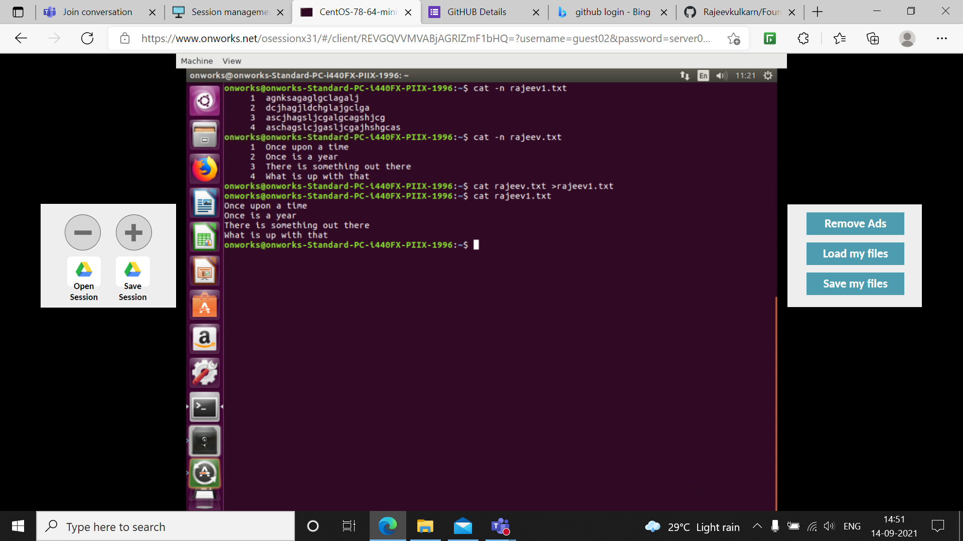

3. vim: This is a command line editor.
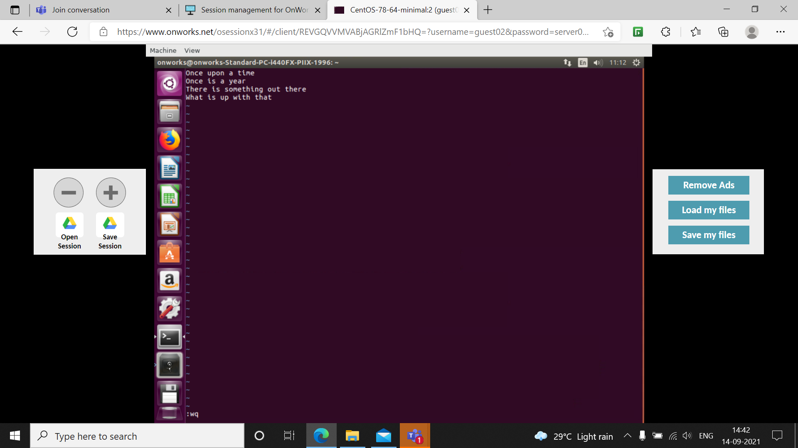

4. head and tail: These commands are used to display the starting or ending 10 lines of the file. 10 lines are by default but we can always change it using
head -n number of lines filename1
tail -n number of lines filename1
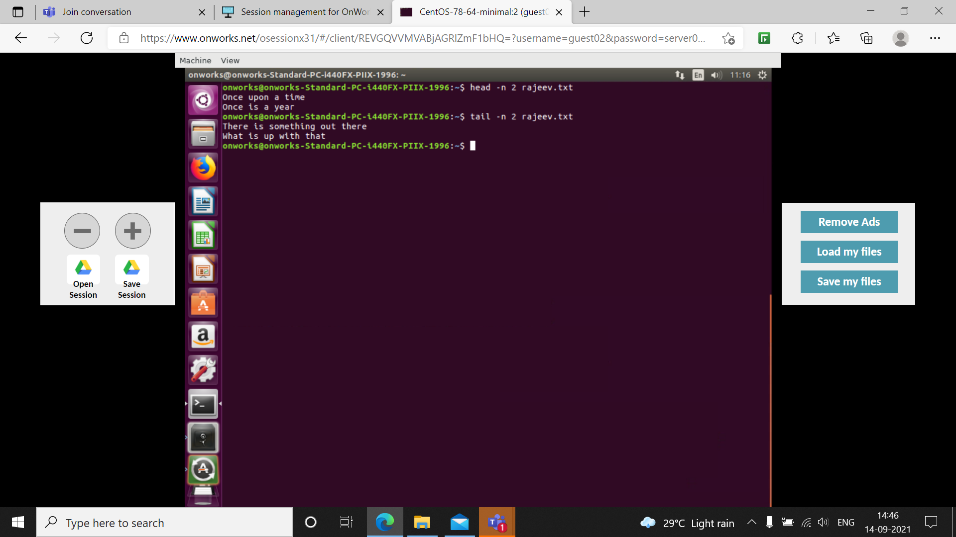

5. grep: This command is used recognize a particular pattern in the file.
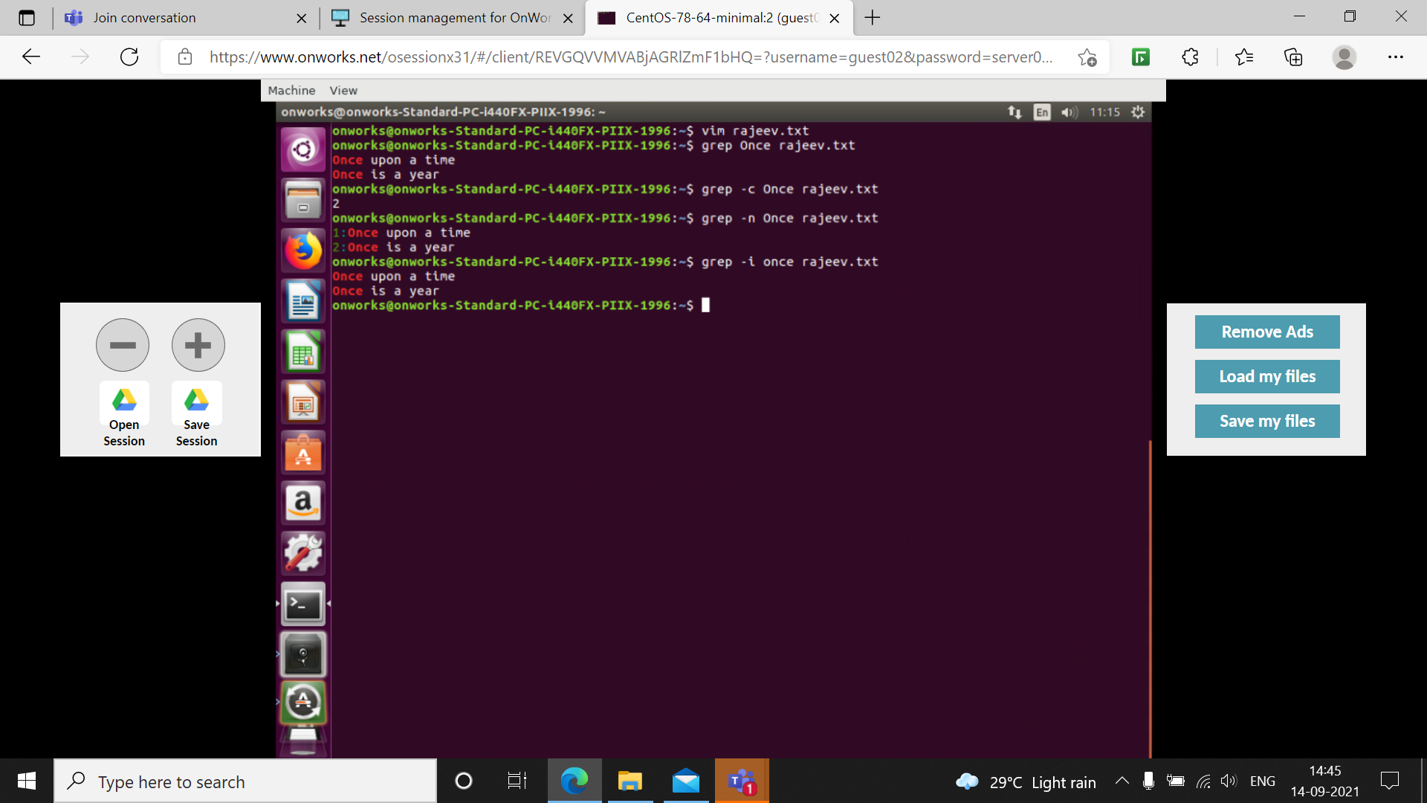

6. uname: This command displays current platform information.

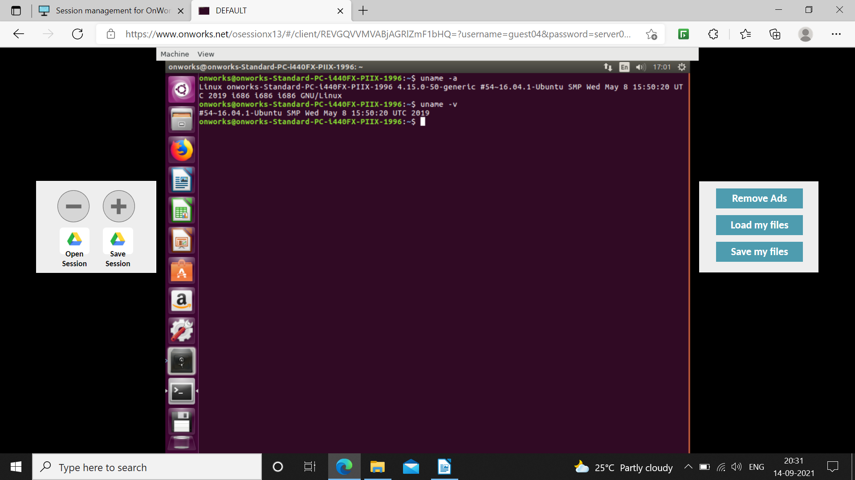

7. wget: It is a non-interactive network downloader. Which checks whether given website is valid or not.
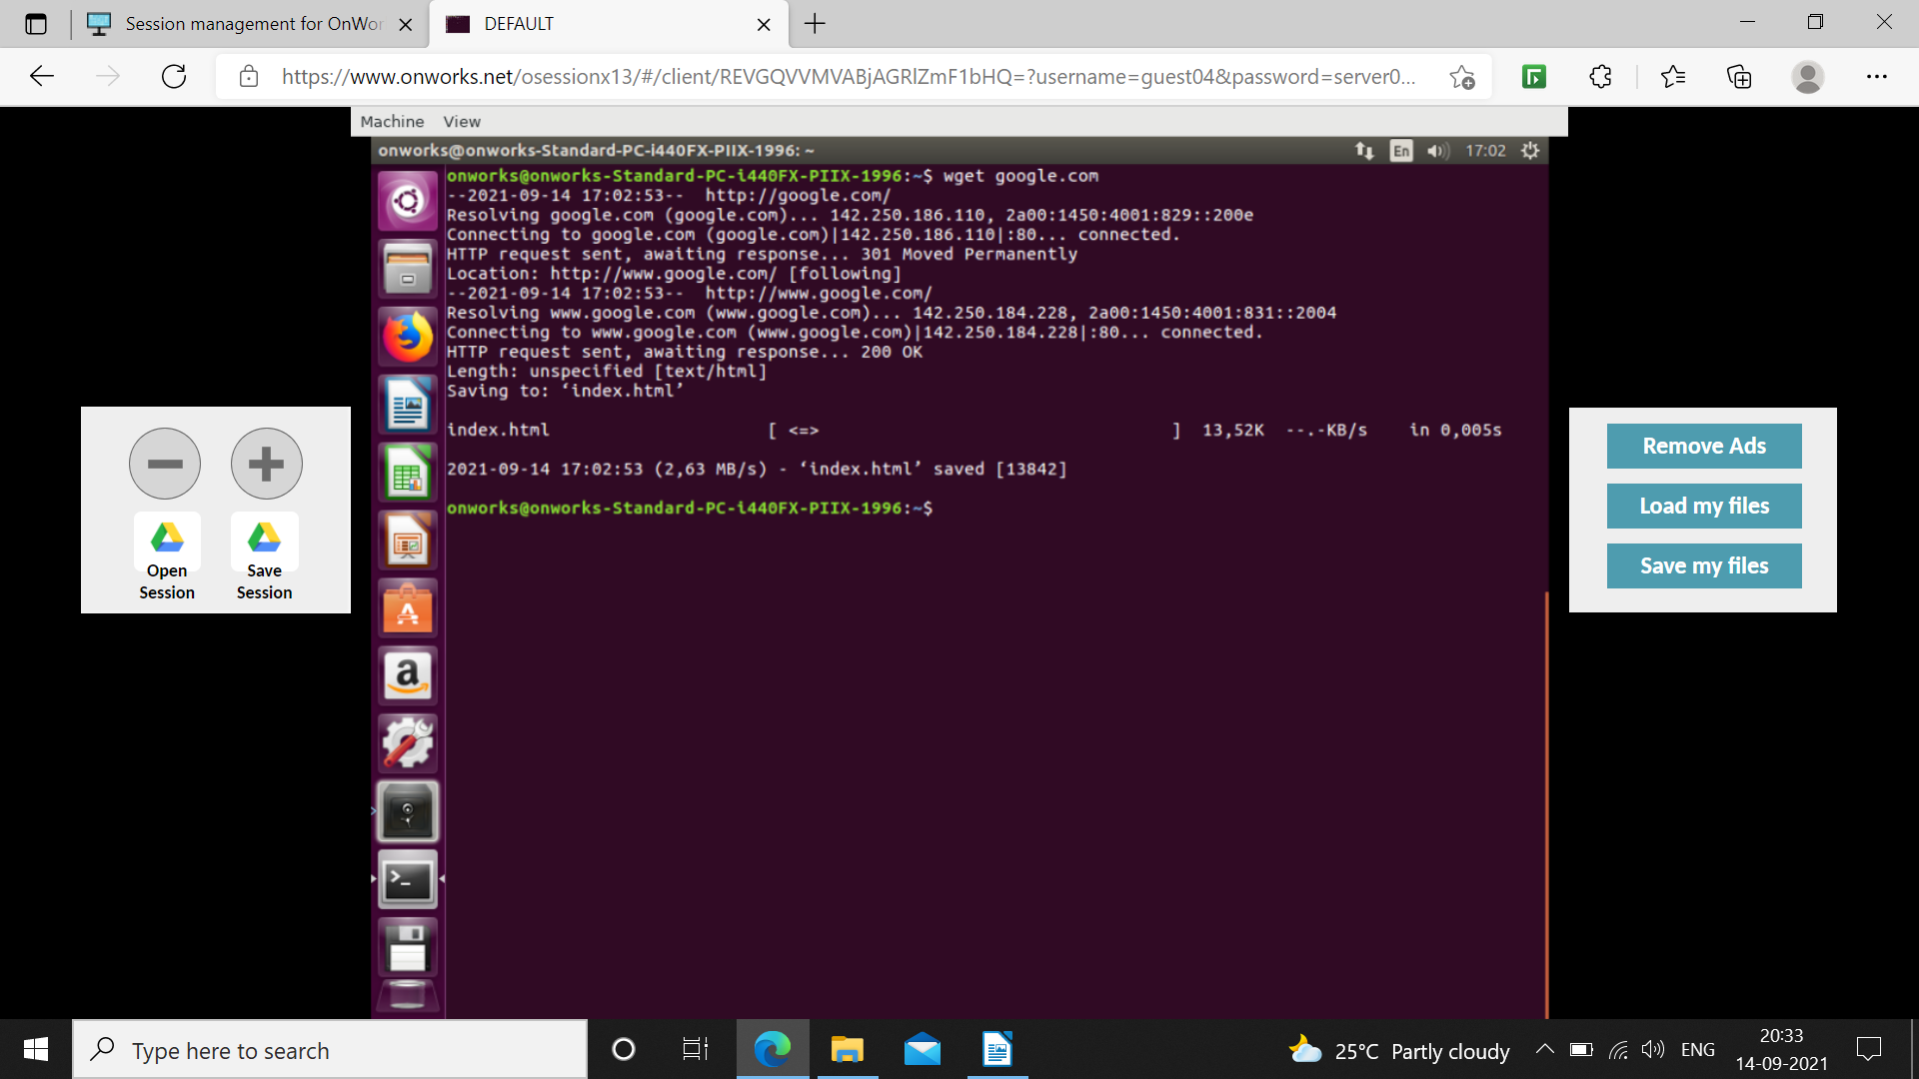

8. ip r and ifconfig: These commands displays network related information.
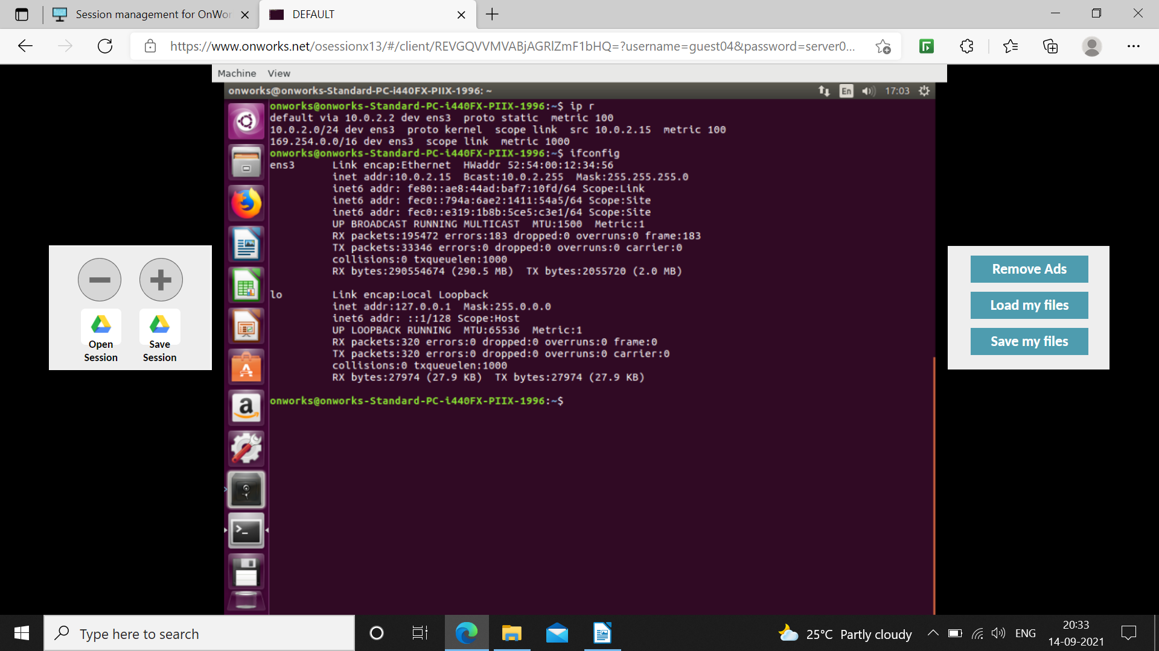

9. history: This command displays all recently used commands.

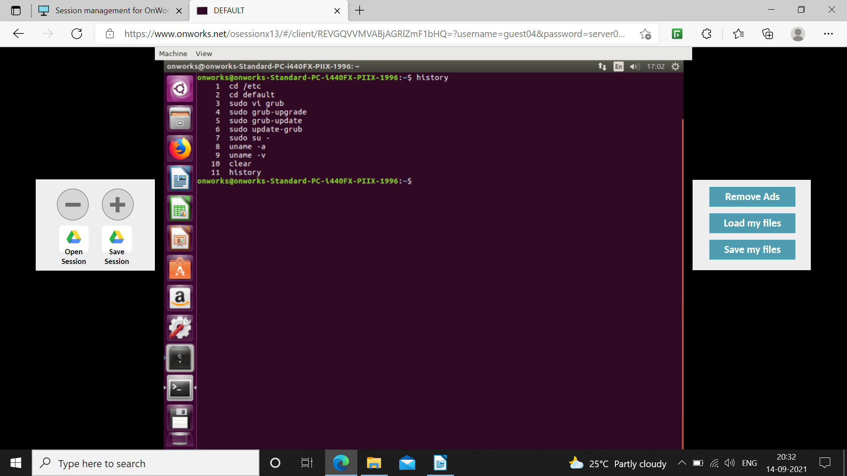

10. hostname, who and whami: These commands displays current user.
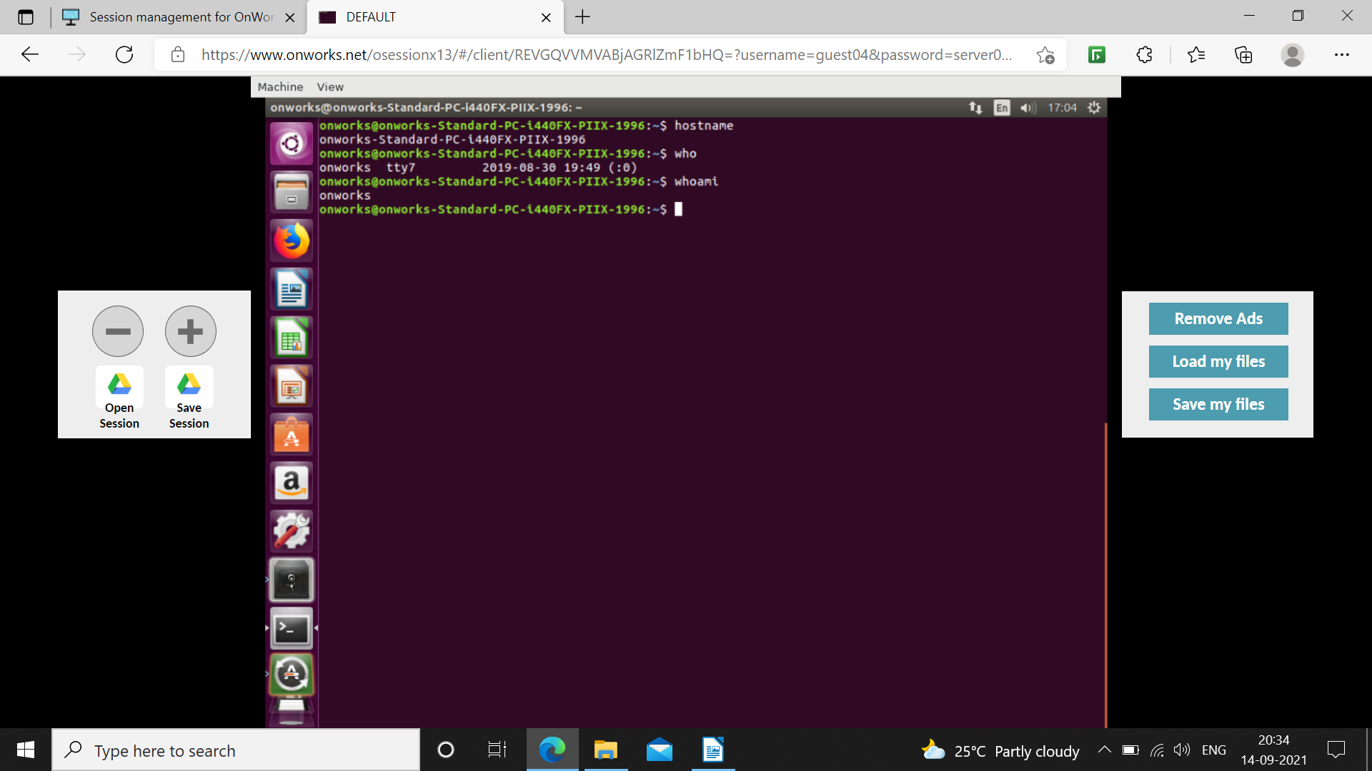

11. alias: This command used to temporarily rename complicated commands.
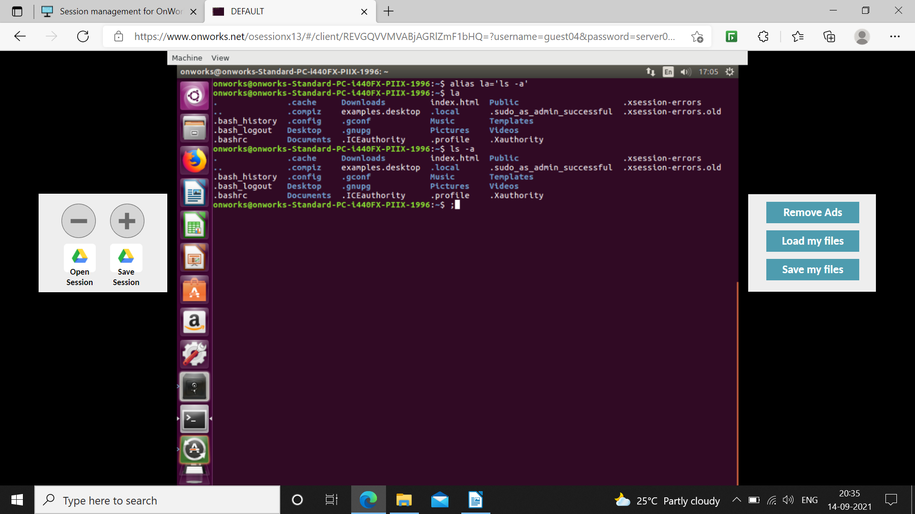

12. wc: This command displays number of lines, number of words and number of bytes of a file.
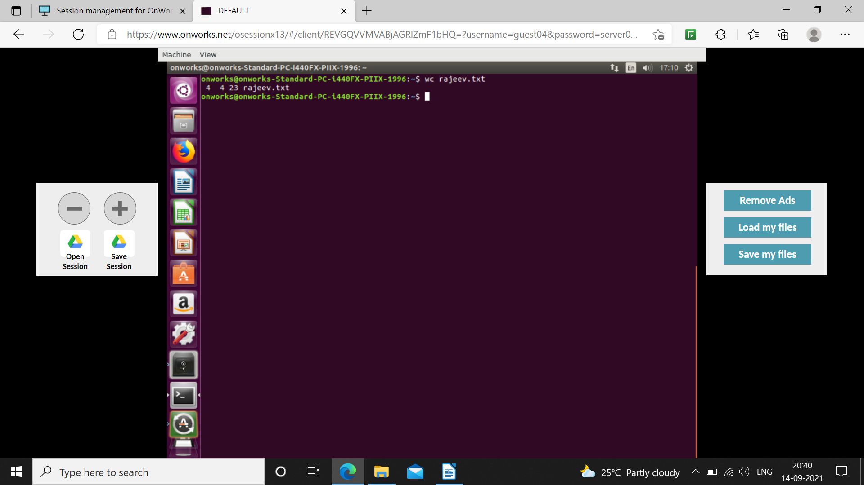

13. sort: This command is used to sort contents of file, according to alphabetical order. If user wants he/she can reverse the order.

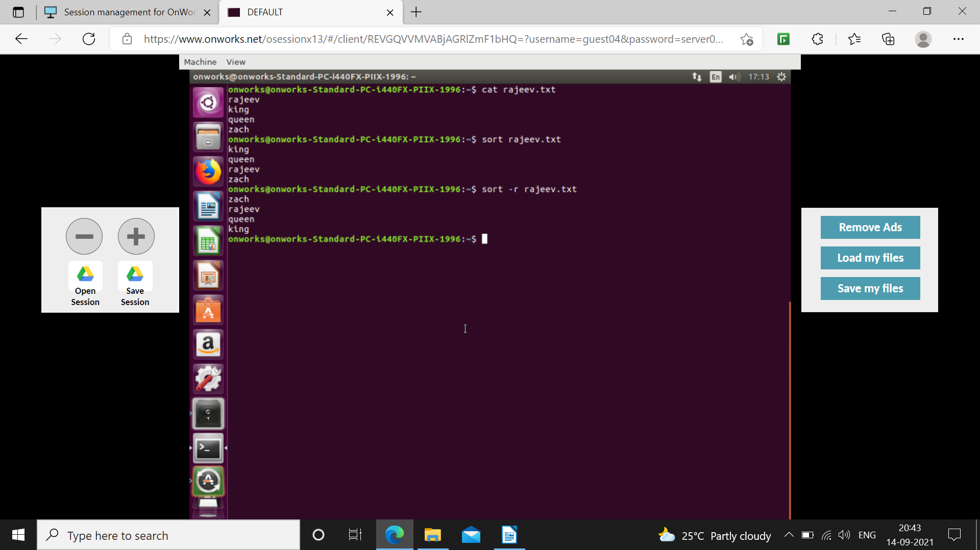

14.diff: Displays difference between two files.


